

InsightScan Rwanda

CASE STUDY: Ministry of Trade and Industry Rwanda Inspectorate, Competition and Consumer Protection Miguel Multi-service ltd



STUDENTS’ PROJECT PROPOSAL



Done By

NDOBA Hakim, # 23951

Major in

Software Engineering

February ,2024

**PART I**

**INTRODUCTION OF THE CURRENT SYSTEM**

**ENVIRONMENT**

**Historical Background**

The Ministry of Trade and Industry (MINICOM) in Rwanda has a relatively young history, established in 2003 following a government reorganization that merged the former Ministry of Commerce and Industry and the Ministry of Tourism and Handicrafts. However, its roots can be traced back to earlier efforts to promote economic development in the country.

Pre-Establishment Efforts:

Colonial Period: During Belgian colonial rule (1916-1962), the focus was on extracting resources and agricultural production for export, with limited emphasis on domestic industry or trade.

Early Independence: After independence in 1962, the Rwandan government established various ministries and departments responsible for trade and industry, but their efforts were often hampered by political instability and economic challenges.

Liberalization in the 1990s: In the 1990s, Rwanda's government adopted a market-oriented economic reform program, leading to the creation of dedicated institutions for trade and industry development.

Establishment of MINICOM in 2003:

Merger of Ministries: In 2003, the government merged the Ministry of Commerce and Industry and the Ministry of Tourism and Handicrafts to form MINICOM. This aimed to streamline efforts and create a more coordinated approach to promoting economic development.

Initial Focus: Initially, MINICOM's primary focus was on creating a conducive environment for private sector growth, attracting foreign investment, and promoting exports.

# Evolution of Roles: Over the years, MINICOM's responsibilities have expanded to include industrial development, entrepreneurship support, consumer protection, and intellectual property rights.

# Key Milestones in MINICOM's History:

# 2006: Launch of Vision 2020: The Rwandan government launched Vision 2020, a national development strategy aiming to transform Rwanda into a knowledge-based, high-income economy. MINICOM played a key role in implementing the strategy's trade and industry objectives.

# 2008: Establishment of Rwanda Development Board (RDB): The RDB was established as a one-stop shop for investors, streamlining business registration and approval processes. This significantly improved Rwanda's ranking in the World Bank's Doing Business report.

# 2014: Adoption of Made in Rwanda Policy: The government launched the Made in Rwanda policy to promote domestic production and exports. This initiative has supported the growth of various industries, including manufacturing, agro-processing, and textiles.

# 2020: Vision 2020 Completion and Vision 2050 Adoption: Vision 2020 was successfully completed, and Rwanda transitioned to Vision 2050, which aims to make Rwanda an upper-middle-income country by 2035 and a high-income, knowledge-based economy by 2050. MINICOM continues to play a critical role in achieving these goals.

# MINICOM's Current Structure and Functions:

# Directorates: MINICOM is currently organized into four directorates: Trade and Investment, Industry and Entrepreneurship, Cooperatives, and Small and Medium Enterprises (SMEs).

# Key Functions: The Ministry's primary functions include formulating and implementing trade and industry policies, promoting exports and foreign investment, developing industrial zones, supporting entrepreneurs, protecting consumers, and ensuring intellectual property rights.

# Challenges and Future Outlook:

# While MINICOM has made significant strides in promoting Rwanda's economic development, challenges remain. These include addressing skills gaps, reducing trade barriers, promoting regional integration, and ensuring inclusive growth.

# Mission

The general mission of the Ministry of Trade and Industry is to lead the development of external and internal trade, competitive companies and cooperatives on the market and promotion of investment and consumer rights.

Specifically, the Ministry of Trade and Industry is responsible for:

* Developing, disseminating and coordinating the implementation of sector policies, strategies and programs related to trade and industry
* Regulating the trade and industry sector and all other attached sectors
* Developing institutional and human resources capacities in the industrial and commercial sector
* Monitoring and evaluating the implementation of sector and sub-sector policies, strategies and programs;
* Overseeing the institutions under its supervision
* Mobilizing the necessary resources for implementing programs
* Conducting bilateral and multilateral trade negotiations aimed at promoting Rwanda’s interests.

**Vision**

* Transforming Rwanda into a high-income, knowledge-based economy
* Building a strong and diversified private sector
* Becoming a regional leader in trade and investment
* Creating a fair and inclusive economy where everyone benefits from prosperity
* Achieving sustainable development goals and environmental protection

These aspirations reflect MINICOM's commitment to not only drive economic growth but also ensure it is sustainable and inclusive for all Rwandans.

# Organizational Structure

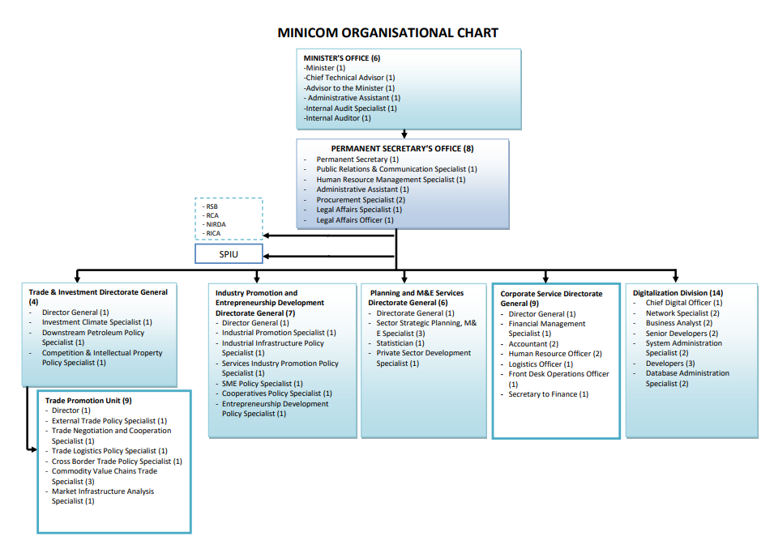

# Core Belief and Values

The Adventist University of Central Africa has the following belief and Value:

* Excellence
* Innovation
* Partnership
* Equity
* Environmental sustainability

**PART II**

**PRESENTATION OF THE CURRENT SYSTEM**

**Description of the Current System**

**Description of the Current System:**

The current system involves conducting market evaluation and competitor analysis to gather data, analyze it, identify competitors, analyze their strategies, assess market positioning, develop action plans, and continuously monitor the market.

**Actors Role and Responsibilities in the Department:**

Data Analyst:

Collects data from various sources.

Analyzes data using tools such as spreadsheets and statistical software.

Identifies market trends, customer preferences, and competitor strategies.

Assesses key metrics such as market share, revenue growth, and customer satisfaction.

Marketing Manager:

Guides the overall market evaluation and competitor analysis process.

Provides guidance for identifying competitors and conducting competitive analysis.

Evaluates the company's market position relative to competitors.

Develops action plans to improve the company's competitive advantage.

Sales Team:

Provides internal sales and customer data.

Shares customer feedback and insights with the marketing team.

Collaborates with the marketing team to align strategies based on the analysis.

The process was like this;

Data Collection:

The Data Analyst collects data from various sources, such as internal sales systems, CRM databases, customer surveys, market research reports, and external data providers.

The Sales Team provides internal sales and customer data, including sales figures, customer profiles, and transactional data.

Data Analysis:

The Data Analyst analyzes the collected data using tools such as spreadsheets, statistical software, and data visualization tools.

They apply data cleaning, transformation, and statistical techniques to extract insights and identify patterns and trends.

The analysis includes identifying market trends, customer preferences, and competitor strategies.

Market Evaluation:

The Marketing Manager guides the overall market evaluation process, leveraging the analysis conducted by the Data Analyst.

They assess the market size, growth potential, customer segments, and key market drivers.

The Marketing Manager evaluates the company's market position relative to competitors and identifies areas for improvement.

Competitor Analysis:

The Marketing Manager, with guidance from the Data Analyst, conducts competitor analysis.

They identify competitors, analyze their strengths, weaknesses, strategies, and product offerings.

The Marketing Manager evaluates competitor positioning, market share, and customer perception.

Strategy Development:

The Marketing Manager takes the lead in developing action plans to improve the company's competitive advantage based on the market evaluation and competitor analysis.

They collaborate with the Data Analyst to incorporate insights gained from data analysis into the strategy development process.

The Sales Team provides customer feedback and insights gathered from customer interactions, which contribute to the strategy development process.

Strategy Alignment:

The Sales Team collaborates closely with the Marketing Manager to align their sales strategies with the insights and recommendations derived from the analysis.

They share customer feedback, market trends, and competitor insights with the marketing team.

Strategy Implementation:

The Marketing Manager, in collaboration with the Sales Team and other relevant stakeholders, oversees the implementation of the developed strategies.

They monitor the progress of the strategies, track key metrics such as market share, revenue growth, and customer satisfaction, and make adjustments as needed.

# AS IS Process Model

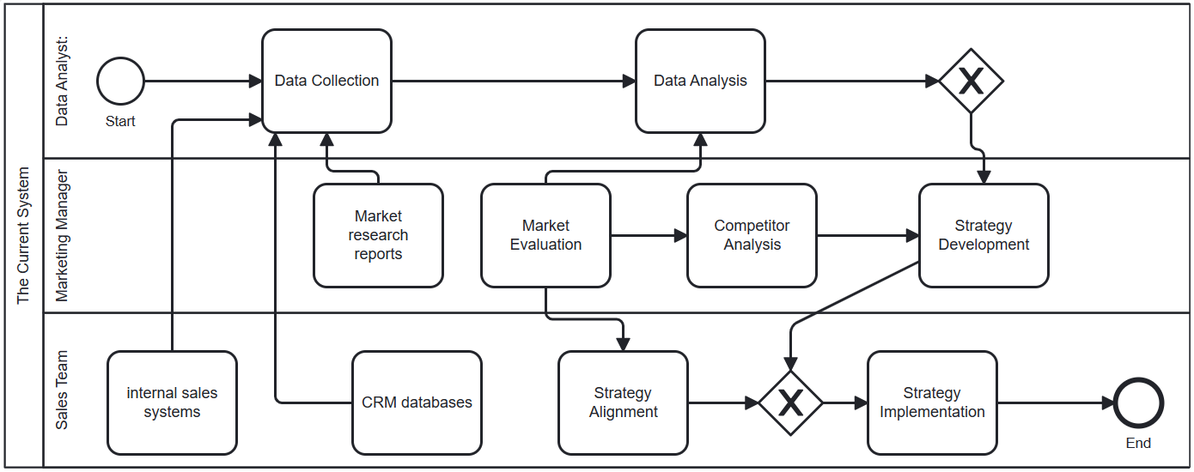

***Figure 1: As Is Process model of the current system.***

**Data Collection:**

- Businesses collect data from various sources, including market research reports, industry publications, government data, customer surveys, and internal sales and customer data.

**Data Analysis:**

- Data analysts analyze the collected data using analytical tools such as spreadsheets, statistical software, and business platforms.

- Analysis involves identifying market trends, customer preferences, competitor strategies, and market opportunities.

**Competitor Identification:**

- Based on the data analysis, businesses identify their direct and indirect competitors in the market.

- Competitors are determined by factors such as similar product offerings, target customer segments, geographic presence, and competitive advantages.

**Competitive Analysis:**

- Businesses conduct a comprehensive analysis of their competitors to understand their strategies, strengths, weaknesses, and market positioning.

- Analysis includes assessing competitor product features, pricing strategies, marketing campaigns, distribution networks, and customer feedback.

**Market Positioning:**

- Businesses evaluate their own market position relative to their competitors.

- This involves understanding their unique value proposition, differentiating factors, and identifying areas for improvement.

- Market positioning may involve targeting specific customer segments, adjusting pricing strategies, enhancing product features, or improving marketing efforts.

**Action Planning:**

- Based on the insights gained from the competitive analysis and market positioning, businesses develop action plans to improve their competitive advantage.

- Action plans may include adjustments to product offerings, pricing strategies, marketing campaigns, distribution channels, or customer service initiatives.

- Goals, timelines, and performance indicators are established to monitor progress and measure the success of the action plans.

**Monitoring and Review:**

- Businesses continuously monitor the market, competitor activities, and customer feedback to stay updated on market dynamics.

- Regular reviews of the market evaluation and competitor analysis process are conducted to identify any necessary adjustments or improvements.

- Feedback loops are established to capture new data and insights, ensuring the market evaluation remains up-to-date.

**PART III**

**PROBLEMS IN THE CURRENT SYSTEM**

**Performance**

* Limited Data Sources: The current system may rely on a limited number of data sources for competitor analysis, which can result in incomplete or biased insights.
* Delayed Data Collection: Obtaining up-to-date data on competitor activities and market trends may be time-consuming, leading to delays in analysis and decision-making.
* Inefficient Data Analysis: The manual analysis process may be prone to errors and inefficiencies, impacting the accuracy and speed of competitor analysis.
* Lack of Real-time Monitoring: The system may lack real-time monitoring capabilities, making it challenging to identify emerging competitor strategies or market shifts promptly.

**Information**

* Inaccurate or Inconsistent Data: Data inconsistencies or inaccuracies in the collected information can affect the reliability and validity of the analysis.
* Data Silos: Data may be stored in disparate systems or departments, making it difficult to access and integrate for comprehensive competitor analysis.
* Limited Market Intelligence: The system may lack access to comprehensive market intelligence, hindering the ability to gather relevant information for competitor analysis.

**Output**

* Inadequate Reporting: The system may not provide comprehensive and actionable reports on competitor analysis, limiting the effectiveness of decision-making.
* Lack of Insights: The output generated may not offer meaningful insights into competitor strategies, making it challenging to formulate effective competitive strategies.

**Storage**

* Inefficient Data Storage: Data storage and organization may not be optimized, leading to difficulties in retrieving and managing competitor data effectively.

**Economics**

* Costly Market Research: Engaging external market research agencies or purchasing market reports can be expensive, especially for smaller businesses with limited budgets.
* Resource Constraints: Limited resources, both in terms of personnel and financial capabilities, may restrict the extent and quality of competitor analysis.

**Control**

* Lack of Standardized Processes: Inconsistent processes for competitor analysis may result in variations in the quality and depth of analysis.
* Ineffective Competitive Benchmarking: Inadequate benchmarking against competitors may hinder the identification of gaps and areas for improvement.

**Efficiency**

* Time-Consuming Processes: The manual nature of the current system can lead to inefficiencies, including time-consuming data collection, analysis, and reporting.
* Manual Data Entry: Dependence on manual data entry can introduce errors and delays in competitor analysis.

**Service**

* Lack of Proactive Insights: The system may not provide proactive alerts or recommendations based on competitor analysis, limiting its value in driving strategic decision-making.
* Limited Customer Support: Inadequate support or guidance for users of the system may hinder effective utilization and adoption.

**PART IV**

**NEW SYSTEM REQUIREMENTS**

**TO-BE Process;**

**User Registration and Login:**

- Users register for an account using their email and create a password.

- After registration, users log in using their credentials to access the platform.

**Enhanced Dashboard:**

- Redesign the dashboard to provide a more intuitive and customizable user experience.

- Users can personalize the dashboard layout, prioritize specific reports, and access relevant analysis at a glance.

**Streamlined Input Data:**

- Implement data integration capabilities to automate the collection of product data from various sources, such as public databases or APIs.

- Users can input data for various products, but the process is streamlined through automated data retrieval and integration.

**Advanced Reporting:**

- Incorporate machine learning algorithms to automate the analysis of input data and generate comprehensive reports.

- Reports provide insights into market standards, competitor analysis, and other relevant metrics with greater accuracy and efficiency.

**Enhanced Competitor Dashboard:**

- Improve the competitor dashboard to provide deeper insights into competitor analysis.

- Utilize machine learning models to analyze competitor data and identify key trends, strategies, and market positioning.

**Advanced Analysis and Prediction:**

- Leverage machine learning algorithms for advanced analysis and prediction.

- Implement algorithms to identify market trends, forecast demand, optimize pricing strategies, and provide data-driven recommendations. And also will do the market forecasting

**Real-Time Updates and Alerts:**

- Implement real-time data updates and alerts for significant market events, competitor activities, or changes in product performance.

- Users receive notifications and can access real-time insights to make timely decisions.

**Enhanced Data Visualization:**

- Enhance data visualization options with more interactive and customizable charts, graphs, and visualizations.

- Provide users with the ability to create personalized dashboards and export visualizations for presentations or further analysis, and also will have to do the Market Forecasting.

**User Management and Collaboration:**

- Improve user management features to allow for easier user onboarding, account management, and collaboration.

- Enable users to collaborate within the platform, share insights, and assign tasks to team members.

# System Requirements

**Functional Requirements:**

REQ 1: The system shall provide a user registration process for creating accounts with email and password. REQ 2: Users shall be able to log in using their credentials to access the platform. REQ 3: The dashboard shall be redesigned to provide a more intuitive and customizable user experience. REQ 4: Users shall be able to personalize the dashboard layout, prioritize specific reports, and access relevant analysis at a glance. REQ 5: The system shall implement data integration capabilities to automate the collection of product data from various sources. REQ 6: Users shall be able to input data for various products, with the process streamlined through automated data retrieval and integration. REQ 7: Machine learning algorithms shall be incorporated to automate the analysis of input data and generate comprehensive reports. REQ 8: The reports shall provide insights into market standards, competitor analysis, and other relevant metrics with accuracy and efficiency. REQ 9: The competitor dashboard shall be improved to provide deeper insights into competitor analysis. REQ 10: Machine learning models shall be utilized to analyze competitor data and identify key trends, strategies, and market positioning. REQ 11: Machine learning algorithms shall be leveraged for advanced analysis and prediction, including identifying market trends, forecasting demand, optimizing pricing strategies, and providing data-driven recommendations. REQ 12: The system shall implement real-time data updates and alerts for significant market events, competitor activities, or changes in product performance. REQ 13: Users shall receive notifications and have access to real-time insights to make timely decisions. REQ 14: The system shall enhance data visualization options with more interactive and customizable charts, graphs, and visualizations. REQ 15: Users shall have the ability to create personalized dashboards and export visualizations for presentations or further analysis. REQ 16: User management features shall be improved to allow for easier user onboarding, account management, and collaboration. REQ 17: Users shall be able to collaborate within the platform, share insights, and assign tasks to team members.

**Non-Functional Requirements:**

**Performance:**

REQ 18: The system must support a minimum of 5,000 concurrent users.

**Scalability:**

REQ 19: The system should be scalable to support a growing user base and increasing data volume.

**Portability:**

REQ 20: The system should be compatible with different operating systems, including Windows and mobile platforms.

**Reliability:**

REQ 21: The system should operate without critical failures in at least 95 percent of use cases during a month.

**Maintainability:**

REQ 22: The system should be designed with modularity and clean code practices for ease of maintenance and future enhancements.

**Security:**

REQ 23: User data and system information should be protected against unauthorized access, ensuring data privacy and security.

**TECHNOLOGY TO BE USED**

**Backend;**

* Programming Languages: Python, Java, or Node.js can be used for server-side development.
* Frameworks: Django, also Express.js can be utilized to build the backend application.
* Database: MySQL, could be suitable for storing and managing data.

**Frontend;**

* HTML/CSS: To structure and style the user interface of the web application.
* JavaScript: To add interactivity and dynamic behavior to the frontend.
* Frameworks/Libraries: React, Angular, can be employed to develop a responsive and user-friendly frontend.

**Data Processing and Analysis:**

* Machine Learning: Libraries such as scikit-learn, TensorFlow, can be used for implementing machine learning algorithms for data analysis and prediction.
* Data Visualization: Libraries like D3.js, Chart.js, or Plotly can be utilized to create interactive and visually appealing charts and graphs.

**Integration and APIs;**

* RESTful APIs: To facilitate communication between different components or external systems.
* API Frameworks: Django REST Framework can be used to build RESTful APIs.
* Authentication and Authorization: Technologies like JSON Web Tokens (JWT) or OAuth can be employed for secure user authentication and authorization.